Due: 11/5 before 10:00 PM
RUBRIC AT BOTTOM
Review the power points - Frankenstein and the Golem, view the summaries and the videos offered.

Additionally go to You tube and for $1.99 rent Kaddish episode ; Discuss in two to three pages the similarities between the legends and the update that is the X-files episode.
The X-Files S4 • E15 on YouTube

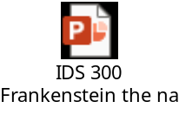
Video Links:
https://youtu.be/N8gCIvFg11I
https://youtu.be/Zoa6mOc163w

